Cypress Woods FFA Member Handbook
2023-2024
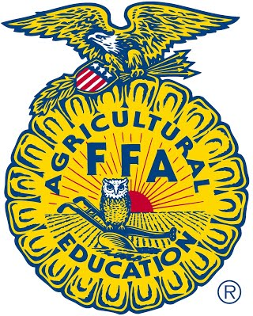
FFA MOTTO:
Learning to Do,
Doing to Learn,
Earning to Live,
Living to Serve.

Table of Contents

General Membership Info …………………………………………………………………………… 3, 4
SchoolCash Online Cheat Sheet ……………………………………………………………………..… 5
Livestock Show Information…. ……………………………………………………………………..… 6
Official Dress Checklist and Order Forms ...………………………..……………………………… 7, 8
Officer Application and Expectations ……...………………………………………………….…… 9, 10
Letter Jacket Requirements …..………………………………………………………………......…… 11
AET Record Book ……………….………………………………………………...……………… 12, 13
CDE, LDE, SDE Travel Process/Agreement……………………………………………………..…… 14
Fundraisers ………………………………………………………………………………….………… 15
Achievements and Awards …………………………………………………………………………… 16
Howdy everyone and welcome to the Cypress Woods FFA Chapter!
My name is Matthew Westfall and I am beyond blessed to be serving another year as the Cy Woods FFA President and I am so excited to meet each and everyone one of you! One of my absolute favorite things about our chapter is the mass amount of opportunities that it offers to both members and parents. Whether you are interested in raising livestock, developing leadership and communication skills, creating floral arrangements, joining a competitive FFA team, or looking for a way to get to know others, our chapter will always encourage you to get involved and try something new. Through the next few pages of this handbook, you will be provided information over how to become active in FFA. From important dates and information to guidelines for official dress, this handbook is filled with things that you will need to know for this upcoming school year. If at any time you have questions, please do not hesitate to reach out. We cannot wait to see you at our first meeting in September and once again welcome to the Cypress Woods FFA Chapter!
Matthew Westfall
2023-2024 Cypress Woods FFA President
2023-2024 Cypress Woods FFA Officers
President – Matthew Westfall (LSA Rep)
Vice President – Ryanne Thompson
Secretary – Katy Oetken
Treasurer – Tessa Powell
Reporter – Kylee Turner
Sentinel – Emma McCrory
Student Advisor – Madison Furch
Cypress Woods Ag Department Contact Info
Mr. Atkins: Kyle.Atkins@cfisd.net
Mrs. Shepherd- Courtney.Shepherd@cfisd.net
Ms. McClellan: Monica.McClellan@cfisd.net
Mr. Meischen: Tyler.Meischen@cfisd.net
Cypress Woods FFA Website / Social Media
Website
http://cypresswoods.ffanow.org
Instagram & Twitter
@cywoodsffa
Facebook
facebook.com/cypresswoodsffa
Tik Tok
@cywoodsffa212

 | FFA MEMBER/STUDENT MEETING | BOOSTER CLUB/PARENT MEETING
Tuesday  SEPT.12th | 7:00 pm @Ag Shop | 7:00 pm @Auditorium
Tuesday  OCT. 10th | 7:00 pm @Ag Shop | 7:00 pm @CW Teaching Theater
Tuesday  NOV. 14th | 7:00 pm @Ag Shop | 7:00 pm @CW Teaching Theater
Tuesday  DEC 12th | 7:00 pm @Ag Shop | 7:00 pm @CW Teaching Theater
Tuesday  JAN. 8th | (General Livestock Show Mtg) @ 6:00 pm @Exhibit Center | Same as FFA
FEB | No monthly meeting | No monthly meeting
Tuesday  MAR. 19th | 7:00 pm @Ag Shop | 7:00 pm @CW Teaching Theater
Tuesday  TBD | Banquet @ CW Commons | Same as FFA
Important Dates
*refer to our chapter website for dates*
Lamb, Goat, Swine Entries Due: Sept 14th • New Member Social: Sept 20th 6-7:30p
Lottery Draw: Oct. 4 • Goat Selection: Oct 5th • Lamb Selection: Oct 6th • Hog Selection: Oct 7th
Craft Show: October 28-29 • Royalty Contest: Dec 2nd • CFISD Livestock Show: Jan 31-Feb 2
FFA Banquet
The annual FFA Banquet is a celebration of the Cypress Woods FFA member’s achievements throughout the year.
Every member and their parents are encouraged to attend. All members should wear their FFA Official Dress.
Banquet will be held in the Cypress Woods FFA Commons
NEW ONLINE ANIMAL PAYMENT CHEAT SHEET
First time set up-parents/guardians:
- Go to Cy Woods website: cywoods.cfisd.net
- Scroll down, lower right side and click on:

- Click on “Register for an Account”.
- Follow prompts: email, password, name, address, phone number, etc.
- Confirm email.
- Link/attach any of your CFISD students to your profile. Info needed: student name, birthdate, home campus.
- As school adds fees, they will show up according to what the student will need to pay for:
Ex: class fees, t-shirts sales, etc.
- We recommend you keep any and all receipts of payment, even though a record of your payment will stay on your profile for reference.

CFISD Livestock Show Association

What? 28th Annual Cypress-Fairbanks ISD Livestock Show and Sale

Where? CFISD Exhibit Center, 11206 Telge Rd, Cypress, TX 77429

When? Judging: January 31-February 2, 2024

Sale: February 3, 2024, Freezer Sale & Silent Auction: 10:00 am, Live Auction: 1:00 pm

Qualifications?
- Enrolled in an Ag class for the 2023-2024 school year

- Entries and payments turned in by due date

- UIL Eligible

For more information please regarding rules and dates visit: https://sites.google.com/cfisd.net/cfisd-lsa/home

*District barns available for sheep, goats, hogs, steers*

Check List for Indoor & Outdoor Official FFA Dress

Female: _____Black skirt. (No denim/jean - blue or black, leather, pleather, etc.) Skirt is to be at least knee length, hemmed evenly across the bottom, with a slit no longer than 2 inches above the knee, excluding the kick pleat. Black skirts are required for the Cypress Woods FFA Banquet in May and all other indoor FFA events. Must wear black nylon hosiery and black dress shoes with skirt – see below.

_____White button-up, collared blouse.

_____ Official FFA blue scarf (without ring). Suggestion: Buy at least 2!

_____ Black dress shoes with a closed heel and toe to wear with black skirt. (No boots, sandals, open-toed shoes, or tennis shoes. NO sequins, sparkles or any other accessories. Suggestion: Flats are best!

_____ Black nylon hosiery to wear with black skirt. Suggestion: Buy multiple pairs!

_____ For CFISD Livestock Show: Solid black jeans/pants, no bling, no white stitching, MUST be completely black from top to bottom, cannot be faded black jeans, boot cut ONLY. No skinny jeans! Must wear solid black, no bling belt with jeans/pants. Belt buckles are acceptable.

_____ For CFISD Livestock Show: Black dress boots are acceptable for official dress. No white or colored stitching on the LEATHER that shows on the vamp (toe/foot) of the boot. The shaft (top/leg) of the boot can be any color as long as it is covered by your pants.

_____ Official FFA Jacket.

_____ Other: Jewelry must be minimal. Hair must be natural colors and well-kept. Natural make-up is suggested.

Male: _____ Black dress pants/slacks. (No jeans - blue or black, leather, pleather, etc.)

_____ For CFISD Livestock Show: Solid black jeans, no bling, no white stitching, MUST be completely black from top to bottom, cannot be faded black jeans, boot cut ONLY. Suggested brand: Men’s Black Wrangler Riata’s (can wear this brand at show and indoor events).

_____ Black belt. (Must wear solid black, no bling belt for all events. Belt buckles are acceptable.)

_____ White button-up, collared dress shirt.

_____ Official FFA tie. (The FFA bowtie is NOT acceptable). Suggestion: Buy at least 2!

_____ Black dress shoes with a closed heel and toe. Dress boots are acceptable for indoor official dress in Texas. (No sandals, open-toed shoes, tennis shoes.)

_____ For CFISD Livestock Show: Black dress boots are acceptable for official dress. No white or colored stitching on the LEATHER that shows on the vamp (toe/foot) of the boot. The shaft (top/leg) of the boot can be any color as long as it is covered by your pants.

_____ Black socks. (Especially important when wearing dress shoes and slacks).

_____ Official FFA Jacket.

_____ Other: Face must be clean-shaven. Jewelry must be minimal. Hair must be natural colors and well-kept.

* Please ask your Ag Teacher if there is any uncertainty about the items to purchase for Official Dress.*
How to Order Your Official FFA Jacket
Size: ________________
- To order your Official FFA Jacket, visit the National FFA- Shop FFA website to begin ordering.
- https://shopffa.org/products?clear=true

- First, make an account as a guest member (new FFA online experience). Once you have your account made, click on the “Official Dress” tab.

- Second, click on “Men’s” (Item #100) or “Women’s” (Item #103) according to the jacket size suggested to your child at the top of the form.

- Then click the icon that says “Jackets” and then click “Official Jacket”.

- Type: “Standard Jacket”

- Size: (The size suggested at the top of the form.)

- Select “Click Here to Personalize”
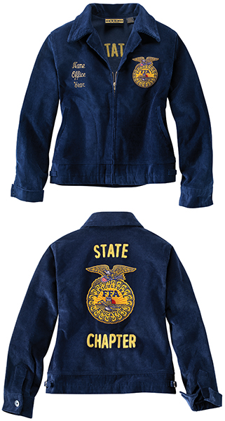
  - Chapter Number: TX1157
  - Advisor Name: Monica McClellan or Tyler Meischen (or Kyle Atkins or Courtney Shepherd)
  - Front Line: (Students First & Last Name)
  - Back State 1: TEXAS
  - Back Chapter Line 2: CYPRESS WOODS

- PLEASE SPELL CHECK BEFORE ORDERING!

- Girls: It is suggested to order 2 scarves. At least one is required of all female members. (No ring scarves).

- Boys: It is suggested to order 2 ties. At least one is required of all male members. (No bowties).

* Please make sure that when you are ordering the jacket that you are ordering the correct size according to the item # written at the top of this page. Students tried on jackets in class and chose sizes according to the fit of the jacket.

* Please read the checklist provided for the complete Official Dress requirements for indoor and outdoor dress, especially for what is required for the CFISD Livestock Show.

Please have a printed receipt to present to your Ag Teacher by December 1st!
Cypress Woods FFA
2024-2025 Chapter Officer Applicant Information
Congratulations on your interest in pursuing a leadership position as a chapter officer serving the Cypress Woods FFA chapter! Becoming a chapter officer is a challenging process, yet a rewarding opportunity. Through this chapter officer candidate process, you will grow as a person, advancing in both leadership development and career preparation.
Cypress Woods FFA is a very large and diverse chapter. During the 2021-2022 school year, there were over 180 members involved in approximately 200 supervised agricultural experiences; therefore, it is critical for chapter officer applicants to consider their potential impact for leadership and responsibility to serve others.
The chapter officer election process is made up of three, equally weighted components listed and described as follows:
- Interview – applicants will be interviewed by a panel of judges and ranked based on their answers to standard leadership questions, vocal presence and strength, sincerity, ability to communicate effectively, and potential for providing genuine leadership. The interview is calculated as 33.3% of an applicant’s total score and serves as the first tiebreaker.

- Officer Exam – a general knowledge exam based on the Official FFA Manual and Parliamentary Guide for FFA. The officer exam is calculated as 33.3% of an applicant’s total score and serves as the second tiebreaker.

- Membership Vote – all current FFA members will cast their vote on during their respective class period. The membership vote is calculated as 33.3% of an applicant’s total score and serves as the third tiebreaker.
This year’s officer exam and interview will be conducted on Wednesday, April 22nd, beginning at 2:50 p.m. in rooms 1902/1904. Officer candidates are expected to participate in these activities, along with the 2023 Cypress Woods FFA Banquet, wearing Official FFA Dress as described in the Official FFA Manual.
Expectations of a Cypress Woods FFA chapter officer will be set up in a demerit system and listed as follows and not limited to:
- Maintaining Academic Eligibility and Outstanding School Attendance

- Maintaining a Clear Discipline Record

- Attending the State FFA Convention – July 2024 in Houston

- Performing the Duties of a FFA Officer as Outlined in the Official FFA Manual

- Attending Monthly Chapter Officer Planning Meetings

- Attending All Monthly FFA Chapter Meetings

- Participating in Chapter Activities

- Assisting Chapter Advisors with Chapter Functions
CYPRESS WOODS FFA
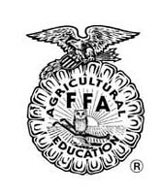
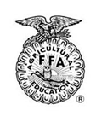
OFFICER DEMERIT SYSTEM

As an officer of the Cypress Woods FFA, you are held to a higher and more specific standard of behavior and dress. The following chart outlines inappropriate activities and resulting demerits.

- Officers cannot receive or exceed 5 demerits, or they will be removed from office
- All officers are expected to know and follow the Chapter Constitution in addition to this demerit system.
- Please note that some FFA activities are last minute items that the Ag teachers were unaware of. All efforts will be made to provide advanced notice to the officers. In the event that advanced notice cannot be given, no demerit will be received. All other scheduled activities are required and officers are expected to attend. The ONLY exception will be for CFISD school activities in which you provide written documentation from the coach or teacher. Work or other excuses are not allowed.
- Officers and their parent(s)/guardian(s) are expected to sign the Acknowledgement of this System before they will be allowed to participate in any Chapter functions and/or receive any benefits of officer.

Infractions: | Demerit(s):
Failure to attend/absence from Chapter Meeting without approved prior written notice | 4
Conduct unbecoming of an FFA officer (verbal warning)+ | 1
Conduct unbecoming of an FFA officer (written warning)+ | 2
Failure to wear complete Official Dress when required | 3
Failure to attend Chapter Officer planning meeting | 2
Failure to wear officer shirt on assigned day and/or meeting | 2
Failure to attend Chapter/District/Area meetings, camps, banquets | 2
Nine-Weeks Failure (removed from office for 2 infractions of this nature) | 2
DMC Assignment for any reason | Removal from Office
Visible tattoos, facial piercing, un-natural hair color while at official FFA Functions | No participation until corrected
Suspension from school for any reason | Removal from Office
ALC Placement | Removal from Office
Other infractions against the CFISD District Policy Handbook | 1 to 4

+ Unbecoming behavior includes but is not limited to the following: inappropriate social media posts or comments. Ill representation of the chapter in public or during school. Gossiping or bullying other members or officers. Publicly announcing they wish to quit the team or chapter.
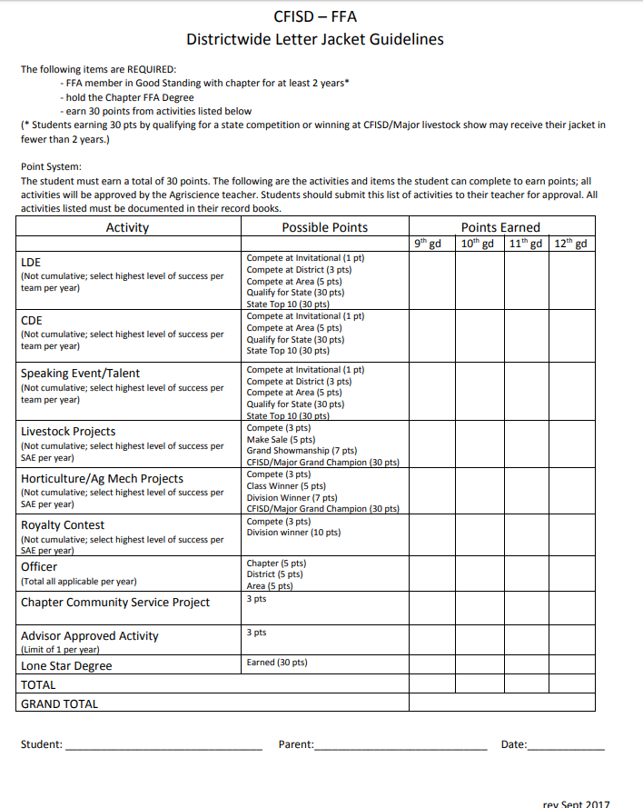
*NEW for 2021* Students will keep track of their own points and then get it checked off by an Ag teacher when they reach 30pts.

*Teachers will no longer discuss letter jacket points during the school day. After school will be the only time points are discussed*
AET Record Book Info
http://www.theaet.com/
Chapter Number: TX1157
See required checklist from the district below under documents.
*CFISD Requires students to complete their record book prior to receiving their LSA Check*
- The following should be completed for each SAE:
  - Profile – Info correct and up to date, add profile picture.
  - Classes – for both semesters.
  - Plan – At least 5 complete sentences for each tab, proper grammar must be used, and your final learning outcome must be entered.
  - Expenses – Everything must be entered up until Sale Day
    - Correct date
    - Proper grammar for vendor name
    - Correct animal/project with correct type of expense
    - ONE item per memo (proper grammar)
  - Income – Teacher will give you the paper with your income information.
    - Date: Sale Day.
    - Vendor: CFISD
    - Correct animal/project with correct type of income
    - Type = Cash/Market Sale
    - Amount = Final total cost
    - Memo = 1 head

Cash Expense | Purchased cash items for your SAE project. | Enter all of your receipts! ONE ITEM FOR MEMO
a. Inventory for Re-sale | The purchase of your SAE project (Animal, Hort or Ag Mech) | Animal Memo: 1 head
b. Feed | The purchase of feed, hay, supplements, etc. for your SAE project | Feed Memo: 50 lbs (per bag)  Hay Memo: Hay, 1 bale
c. Vet Medicine | The purchase of vet medicine (dewormer, betadine, antibiotics, vet visits, etc.) for your SAE project | Memo: Dewormer, 1 tube  Memo: Betadine, 1 bottle
d. Supplies | The purchase of supplies (shavings, halter, buckets, brush, hog whip, poop scooper, etc.) for your SAE project | Memo: Bucket  Shavings Memo: Shavings, 5 bags
e. Repairs/Maintenance | The purchase of supplies for repairs/maintenance for your SAE project. | Memo: Wooden boards for pen  Memo: Supplies to build pens at home
f. Rent | The purchase of rent for your SAE project | Memo: Telge Barn Rent
g. Entry Fee | The purchase of entry fees for competitions with your SAE project. | Memo: HLSR Entry Fee

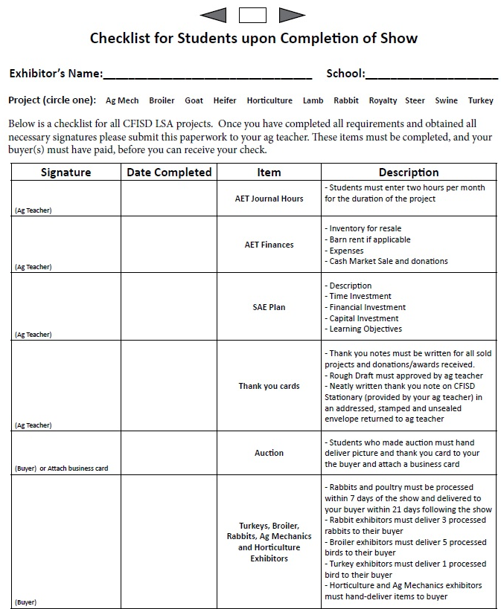

Cypress Woods FFA Chapter CDE / LDE / Travel Agreement Information
If a student fails to attend a contest that has already been paid for by the chapter or booster club, that student and family is fully responsible for all financial costs pertaining to the event or trip. These charges may include: entry and registration fees, hotel costs, and pre-paid meals.
All students traveling must have the CTE Parental Permission Slip and Medical Authorization Forms completed prior to the trip and turned into the Ag Science Teachers.
Any student found in violation of the student code of conduct and/or sent to DMC, ALC, or has been suspended for any reason, is no longer eligible to travel with the Cypress Woods FFA Chapter for that year. If school administration or parents are called at any point on a trip for the student’s behavior, his or her travel privileges may be revoked. Agricultural Science Teachers reserve the right to search student belongings before trips.
CWHS FFA CDE/LDE Team Qualification Process

CDE- Career Development Events (Judging Teams)

The top 4 student’s highest average scores for each team will be the students who are eligible to represent Cypress Woods FFA at the Area III Contest, which is the single qualifying contest to advance to the State Contest.

Method of team calculation: If a student misses a contest for any reason (unless it is for another FFA event at the same time), he or she will receive a score of 0 for that contest. In the average calculation to determine team members, each member is allotted one “drop score”. If a student receives a 0 for missing a contest, that score may be dropped. If no contests are missed, the lowest score will be dropped.

Each team will consist of 3 to 4 members at area, which is the minimum requirement to build a team.

Any FFA Member who is interested in participating on a leadership and/or judging team will have the opportunity to do so as long as they are meeting UIL eligibility requirements and following the CFISD Code of Conduct. All members on judging teams are ultimately up to teacher's discretion. Practices and workshops may be used as a tie breaker if the need arises.

The number of contests available to attend throughout the year is different for each team. We try to attend as many contests with each team as we are able to.

Students who have previously participated on a team, attended previous contests, workshops, clinics, and/or practices are not guaranteed a spot on the team for the next season. They must display the same effort and are expected to meet the same expectations of all new students who are interested in participating on the team each contest season.

We take pride in the fact that our FFA leadership and judging teams are very competitive, just like everything else we do at Cypress Woods. Our students work hard and have a lot of fun too! We are so proud of them.
LDE- Leadership Development Events & SDE- Speaking Development Events
Students competing for LDEs and SDEs must attend all practices. The final winners of each event that will move on to represent Cypress Woods FFA at the Area Contest will be scored and judged by a 3rd party based on Texas FFA LDE and SDE Rubrics.
Fresh Country Fundraiser
Fundraiser will be in the Fall semester. Orders will be ready before Thanksgiving.
Student must arrange a pickup of items on the day assigned due to the fact the items need to be refrigerated and or frozen.
If any money is owed to the chapter, the student will be put on fines and fees and will not be able to exempt until the amount owed is turned in.
The student with the most items sold will receive a belt buckle at the banquet provided by Fresh Country.
All sales will be recorded through iFreshCountry. The code to sign up and sell with our chapter is CWF2805.
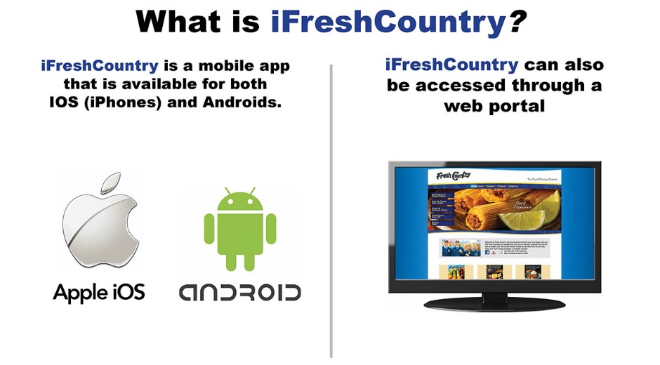

All booster club information and their fundraising information can be found on our website under the booster club tab.

Achievements and Awards
The following awards are handed out at Banquet:
Proficiencies- there are 18 different essay topics. The members are given time in class to complete a 1 page report on the topic. Members then submit it for an award and a 3rd party judge picks out the winner of each topic. The following topics available are as followed: Beef Production, Swine Production, Sheep Production, Goat Production, Poultry Production, Specialty Animal Production (Rabbits), Diversified Livestock Production, Small Animal Production and Care (Pets),Vet Science, Equine Science, Ag Mechanics, Designs, and Fabrication, Ag Sales, Wildlife Production and Management, Fruit Production, Vegetable Production, Dairy Production, Floriculture, and Diversified Agricultural Production.
Star Green Hand, Star Chapter Farmer, and Most Outstanding Senior- this award is based off of member participation in events and activities such as LDEs, CDEs, Livestock Shows, Tour guiding, FFA Day at the Capital, Officer, etc.

The following awards are handed out at the State FFA Convention:
Lone Star Degree- To receive a State FFA Degree, members must meet the following requirements:
• Received a Chapter FFA Degree.
• Have been an active FFA member for at least two years (24 months) at the time of receiving the State FFA Degree
• Have completed at least 2 years (360 hours) of systematic school instruction in agricultural education at our above the ninth grade level, which includes an SAE.
• Have earned and productively invested at least $1000 and worked at least 300 hours in excess of scheduled class time, in a supervised agricultural experience program. The combination of hours and earnings multiplied by a factor of 3.33 must be equal to or greater than the number 1,000.
• Demonstrated leadership ability by performing 10 parliamentary law procedures, giving a six-minute speech on a topic relating to agriculture or FFA, and serving as an FFA officer, committee chairperson, or committee member.
• Have a satisfactory academic record, certified by the agriculture teacher and the school principal or superintendent.
• Participated in the planning and implementation of the chapter’s Program of Activities.
• As of April 1, have completed ten activities above the chapter level in at least three of six different categories: leadership development events, career development events, conventions and meetings, project shows, student awards and leadership and service as described in policies adopted by the Board of Directors.
• Complete at least 25 hours of community service in a minimum of two different activities. All community service hours are cumulative, i.e. the 10 community service hours used to obtain the chapter degree can be used toward the state degree.

**The above requirements are to be recorded in the student’s AET record book in a precise and accurate manner. The student must keep accurate records year after year and work closely with an Ag Science Teacher to complete the checklist. There is a degree check the student must attend in indoor official dress.**
Cypress Woods FFA Handbook Acknowledgement Form
By completing the information below, the student, along with his or her parents, acknowledge the information provided in the Cypress Woods FFA Membership Handbook and general expectations outlined for a Cypress Woods FFA chapter member. A copy of the Chapter Handbook can be found at the Cypress Woods FFA Website (https://cypresswoods.ffanow.org) under the Important Docs tab.

Applicant’s Name (Print): ___________________________________________________________

Applicant’s Signature: __________________________________________ Date: _______________

Guardian Name (Print):_____________________________________________________________

Guardian Signature: ____________________________________________ Date: _______________

Please fill out the following for the AET / Ag Teacher’s records.

STUDENT INFO:

Student’s Full Name: _______________________________________________ Shirt Size: ____________
Nick Name: _________________________Birthdate: _____________ Graduation Year: ______________
Mailing Address: _______________________________________________________________________
City, State, Zip: ________________________________________________________________________
Student ID #: _______________ Home Phone: _________________ Cell Phone: ____________________
Email: _______________________________________________ Best way to contact: _______________

GUARDIAN INFO:

Name: __________________________________________________ Occupation: __________________
Best Phone Number: _________________________ Email: _____________________________________

GUARDIAN INFO:

Name: __________________________________________________ Occupation: __________________
Best Phone Number: _________________________ Email: _____________________________________

Thank you!

